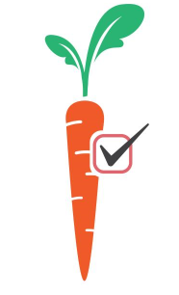
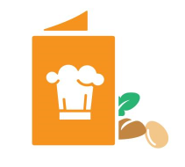
- Juice is not included on any planned menu for infants
- Non-creditable food items, such as ‘cheese food’ are not included in any planned menus for infants
- Only iron-fortified, FDA regulated infant formula or breast milk are included as part of a reimbursable meal for infants
- Yogurt contains no more than 23 grams of sugar per 6 ounces
- Ready to eat breakfast cereal contains no more than 6 grams of sugar per dry ounce
- Infant cereal included as part of a reimbursable meal is iron fortified
- Tofu is not creditable as part of any infant meals
- Infants are offered all required meal pattern components as they are developmentally ready to receive them
- Serving sizes offered are correct for each age group
- Staff are trained on appropriate documentation for mothers who choose to breastfeed on site
- Parents provide no more than one (1) meal component (including breast milk) as part of a reimbursable infant meal
- The center offers at least one variety of creditable formula for infants participating in the CACFP
- All infants in care at the time of service are offered participation in the CACFP
- Medical statements are maintained for any modifications to infant meals that are not compliant with meal pattern requirements
- Documentation of specific food items and quantities offered to each infant on a daily basis, at each meal period, is maintained on site at the center

